## CS 135I - Week 4 Activities

### Getting Ready

* Complete the online readings from this week’s Moodle unit, ideally *in advance* of our class meeting. We’ll want to use every moment of class digging into the practicalities of working with personas and design boards as initial site planning/client communication tools, so be ready!
* Make sure you sign up for a free account on the [Canva](https://www.canva.com/) website and explore using the templates as we will be directly working with these during our class work.

### Class work

* As a group, create a sample persona aggregating some aspect of end-user needs for a website. While the HOW of creating the persona is up to you, it should include
  + Name and basic (relevant) biographical information about your persona
  + Visual representation of your persona
  + 2-3 main goals of your persona  
    Note that these are "big picture" goals
  + 2-3 site tasks the persona would complete in furtherance of each goal  
    Note that these should be a specific interaction the user would have with a website to further one or more of their main goals
* As time allows, prepare for an initial client interview. Create an **idea file** to guide the conversation. The idea file should contain
  + Links and/or screenshots of sites that have relevant content, structure, or design elements that might appeal to the client and/or the client's target audience
  + At least **two different design boards** demonstrating font, color, and/or graphical inspirations.

### Homework

* Create a folder named *yourLastName-hw04*
* Inside of your folder add a file that either contains your group's first persona and customer journey =or= links to that information (10 points)
* Create a second persona representing another segment of users of your website, along with a customer scenario/journey. Add this file to your folder or add a file that links to the information (20 points)
* If you did not finish your idea file as a group, complete creating your links/screenshots of live websites with relevant ideas and polish off your design boards to have them ready to present and discuss in next week's class. It is okay if you and your group members have some variations in the screenshots and design boards. Add this information to your folder (or add files that link to the information (20 points)
* Create a sample page using some of the elements from your personas and idea files developed in class and expanded in homework. (50 points)  
  The page should demonstrate:
  + Correct HTML 5 code, including structural, semantic markup elements, a document type declaration, appropriate indentation, etc.
  + Font formatting, colors, and other formatting applied via an external or embedded stylesheet.
  + Content presentation and weighting that reflects the needs of your personas.  
    Note that it is okay to use lorem ipsum text for larger text areas, but your headlines, link text, image captions, etc. should all be text that you've generated reflecting user needs.

### 

### Notes & Examples

* **Sample Design Board**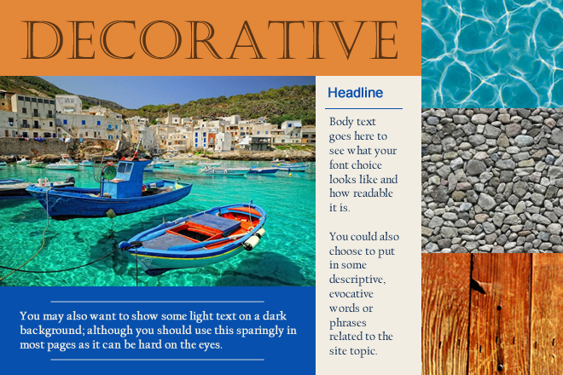
* **Case Studies**
  + Jennifer Abrigado owns Buon Cibo, a new Italian restaurant on Stark Street focused on organic, local Northwest ingredients fused with the rustic Italian recipes of Umbria, a beautiful region of central Italy. She’d like a website that conveys her commitment to sustainability and that draws in customers ready for hearty, warming food.
  + Clackamas Landscape Supply is looking for a refresh of their current website ([www.clackamaslandscapesupply.com](http://www.clackamaslandscapesupply.com/)) to reflect a more modern sensibility as well as foster new business from high end homeowners and contractors.
  + KidsCare is a non-profit organization that connects low income families with free or low-cost dental care. They need a website that communicates the services they provide and encourages donors to sponsor individual children and/or families.
* **Lecture Notes**
  + Content is King
    - Problem: Content is published that is readily available that is not necessarily of interest to the average web user
    - Goal: only publish content that solves actual problems
      * Identify the problems of stakeholders in the website
        + Owners of the website
        + Visitors to the website
      * Ex: community college
        + Overall college business

Publish all information in an accessible manner

Information about classes, degrees, programs

Registration automation

Facilitate communication between the college and students

Strengthen ties with the community (solidify support for scholarship drives/bond efforts/ballot measures)

* + - * + Department business

Facilitate communication between faculty

Communicate when the department staffed/available

* + - * + Users of the website - Users of the website are not always a cohesive group

Current students

Group by degree/program?

Group by full time/part time?

Prospective students

Continuing/community education students

Faculty

Donors

Third party business connections

Alumni

* + - * + Be as specific as possible about the user demographics, needs, values, etc.
    - Personas – fictionalized, specific example of a user in one of your identified categories
      * Persona Example – community college alumni



* + - * Name: Jane Doe  
        Note: you’d want something more persuasively realistic to your audience category and demographic
      * Age: 54 years old
      * Degree: B.A. in English from Portland State (2005) after completing AAOT degree from CCC (2003)
      * Job: Self-published author
      * Lives: Pearl District – doesn’t make it out to Clackamas frequently, but would love to be a visiting author, or maybe she’s interested in the summer theater
      * Technically inclined: committed to the hipster lifestyle; she prefers her vintage typewriter to computers, but, owing to her recently completed degree she has functional word processing and Internet research skills.
      * Family: she’s single, two adopted adult children who still live in her Pearl District Apartment
      * Other connections to the college or local educational organizations: her daughter also currently attends CCC with a goal of transferring to PSU; her son graduated from OSU.
    - Persona’s Site Goals
      * Contribute monetarily to the college community (put her on name on stuff)
      * Researching backgrounds for current stories in development – finding courses/experiences that connect with story topics
      * Etc.
    - Specific Site Tasks
      * Find the phone number for the College Foundation – the person in charge of scholarships, endowed seats, etc.
      * Find out how to register for a course without responsibility for a grade
      * Actually complete that registration